A

Project Report On

**AUTOMATED SOIL MOISTURE IRRIGATION SYSTEM**

Under the Course “Environmental Science” (SH 2174)

Submitted by

Second Year B. Tech. (Computer Engineering )

|  |  |  |
| --- | --- | --- |
| Sr. No. | Student Name | Enroll. No. |
| 1. | Ms. Srushti Yadav | 2403037 |
| 2. | Ms. Pranita Nikam | 2403038 |
| 3. | Mr. Harshal Jadhav | 2403039 |
| 4. | Ms. Vaishnavi Patil | 2403040 |

Under the Guidance of

Guide Name :- Mr.D.R.PATIL



Department of Computer Engineering

K. E. Society’s

**Rajarambapu Institute of Technology, Rajaramnagar**

(An Autonomous Institute Affiliated to Shivaji University, Kolhapur)

**2025-26**

K. E. Society’s

**Rajarambapu Institute of Technology, Rajaramnagar**

(An Autonomous Institute Affiliated to Shivaji University, Kolhapur)

------------------------------------------------------------------------------------------------

**CERTIFICATE**

This is to certify that below mentioned students of S.Y.B.Tech. (CSE) have successfully completed the project entitled ***“*AUTOMATED SOIL MOISTURE IRRIGATION SYSTEM *”*** under the course “Environmental Science” (SH2174). The content of this report, in full or in parts, have not been submitted to any other institution or university for the award of any degree.

|  |  |  |
| --- | --- | --- |
| Sr. No. | Student Name | Enroll. No. |
| 1. | Ms. Srushti Yadav | 2403037 |
| 2. | Ms. Pranita Nikam | 2403038 |
| 3. | Mr. Harshal Jadhav | 2403039 |
| 4. | Ms. Vaishnavi Patil | 2403040 |

Project Guide Project Co-ordinator Head of Department

Place : R.I.T., Rajaramnagar

Date :

**DECLARATION**

We, the undersigned, the students of S. Y. B. Tech. (CSE) hereby declare that the project the project entitled ***“*AUTOMATED SOIL MOISTURE IRRIGATION SYSTEM *”*** under the course “Environmental Science” (SH2174) is a genuine work conducted by us through practical on–site observations, and the data collected by us is true to the extent of our awareness.

|  |  |  |  |
| --- | --- | --- | --- |
| Sr. No. | Student Name | Enroll. No. | Signature |
| 1. | Ms. Srushti Yadav | 2403037 |  |
| 2. | Ms. Pranita Nikam | 2403038 |  |
| 3. | Mr. Harshal Jadhav | 2403039 |  |
| 4. | Ms. Vaishnavi Patil | 2403040 |  |

Place : R.I.T., Rajaramnagar

Date :

**ACKNOWLEDGEMENT**

I take this opportunity to thank all those who have contributed in the successful completion of project work entitled “**AUTOMATED SOIL MOISTURE IRRIGATION SYSTEM** ”. I sincerely wish to express my gratitude to Project Guide Prof. D. R. Patil for full support, expert guidance, encouragement and kind cooperation throughout the project work. I am greatly indebted to him for his help throughout project work.

I express my sincere gratitude towards Dr. S. S. Patil , Head of the Department, Computer Engineering for providing necessary facilities, guidance and support. I am thankful to and fortunate enough to get constant encouragement, support and guidance from all Teaching staffs of Computer Engineering Department, which helped us in successfully completing our project work.

Also, I would like to extend my sincere esteems to all staff in the laboratory for their timely support. Nevertheless, I express my gratitude toward my families and colleagues for their kind co-operation and encouragement which help me in the completion of this project.

Place : R.I.T., Rajaramnagar

Date :

**ABSTRACT**

**Urban farming and small-scale gardening are becoming increasingly popular, but one of the major challenges faced by growers is ensuring consistent and adequate irrigation. Manual watering methods are time-consuming, labor-intensive, and often result in problems such as overwatering, underwatering, and wastage of water. These irregularities not only reduce plant growth and yield but also discourage sustainable gardening practices in urban areas where time, space, and water are limited. To address these issues, this project proposes the design and implementation of an automated soil moisture-based irrigation system using Arduino.**

**The system utilizes a capacitive soil moisture sensor to monitor soil conditions in real time. When the moisture level falls below a predefined threshold, the Arduino microcontroller activates a relay that switches on a submersible water pump. The pump irrigates the soil until the desired moisture level is reached, after which the system automatically turns it off. This ensures optimal irrigation without human intervention.**

**The proposed system is cost-effective, user-friendly, and scalable, making it highly suitable for home gardens, balconies, and rooftop farming. By reducing water wastage, minimizing human effort, and maintaining healthy soil conditions, this project contributes to sustainable urban agriculture and promotes eco-friendly practices for future smart farming solutions.**

**Contents**

|  |  |  |
| --- | --- | --- |
| **Chapter No.** | **Content** | **Page No.** |
| Chapter 1 | Introduction |  |
|  | 1.1 Background Information |  |
|  | 1.2 Problem Statement |  |
|  | 1.3 Project Objectives |  |
| Chapter 2 | Literature Review |  |
| Chapter 3 | Methodology |  |
|  | 3.1 Flow sheet of methodology |  |
|  | 3.2 Step by step detailed methodology |  |
| Chapter 4 | Hardware and Software Requirement; if any |  |
| Chapter 5 | Result and Discussions |  |
| Chapter 6 | Conclusion |  |
| Chapter 7 | Future Scope |  |
| Chapter 8 | References |  |
|  | Time Frame/Activity Chart |  |
|  | User Manual: if applicable   * List of Sensor/Components used in project with detail Information. * Step wise procedure of installation and their connection.   Snapshots of working model.-necessary |  |

**Note: Attach CD which includes program code and required software. (Applicable for software based projects)**

**General guidelines:**

* Header: Topic name
* Footer: Page no. and Department name (Department of IT)
* Font: Times New roman
* Font size:12
* Chapter should start on new page.
* Figures, Tables etc. should be numbered clearly. (Fig. No. 1, Table No. 1)
* References should be written in given format
  + **(Author names.,(year).Name of research paper.name of research Journal,Page no.(e.g.** Beccari, M., Bonemazzi, F., Majone, M. and Riccardi, C., (1996). Interaction between acidogenesis and methanogenesis in the anaerobic treatment of olive oil mill effluents. Water Research 30, 183–189)

**INTRODUCTION**

1. **Background Information :-**

**Urban farming and small-scale gardening are growing in importance due to space and food security needs.Manual irrigation methods are time-consuming, labor-intensive, and inconsistent.Overwatering and underwatering lead to poor plant growth and water wastage.With water scarcity and busy lifestyles, there is a need for automated and efficient irrigation systems.Arduino-based smart irrigation using soil moisture sensors provides a low-cost, sustainable solution.**

**2.PROBLEM STATEMENT:**

**Urban farming and small-scale gardening face significant challenges in providing consistent and adequate irrigation. Manual watering often leads to overwatering or underwatering, which can damage plant roots, reduce growth, and lower overall productivity. It is time-consuming and labor-intensive, requiring constant monitoring to ensure plants receive the right amount of water at the right time. In urban areas, where space, water, and time are limited, these problems are more pronounced. Existing manual irrigation methods are inefficient, waste water, and may fail to respond to changing soil conditions. Therefore, there is a need for a low-cost, automated irrigation system that can monitor soil moisture in real-time, supply water only when necessary, save water, reduce human effort, and maintain healthy plant growth in small-scale and urban gardening setups.**

**3.OBJECTIVES**

**1. Design and implement an Arduino-based automated irrigation system.**

**2. Reduce water wastage by irrigating only when soil moisture is low.**

**3. Eliminate the need for manual watering in small-scale gardening.**

**4. Maintain consistent soil moisture for healthy plant growth.**

**5. Provide a low-cost, scalable, and user-friendly solution for home gardens, rooftops, and balconies.**

**LITERATURE REVIEW**

**[1] Malwe, P. D. (2025) – “A Solar-Powered Automated Irrigation System Using Arduino and Moisture Sensors for Efficient Water Management in Agriculture” This research presents a smart irrigation system that combines automation, renewable energy, and sensor technology to improve agricultural water management. The system is designed using an Arduino Uno microcontroller, which receives input from a capacitive soil moisture sensor placed in the field. When the soil moisture level drops below a pre-set threshold, the Arduino signals a solar-powered water pump to start irrigation. This eliminates the need for constant human supervision and ensures that water is supplied only when required, thus preventing both under- and over-irrigation. By incorporating solar energy, the system becomes energy-independent, which is especially beneficial in remote or rural areas where electricity is either costly or unavailable. Malwe emphasizes that the system not only conserves water but also reduces farmers’ dependence on manual labor, allowing them to focus on other agricultural tasks. Field trials demonstrated reliability, adaptability to different soil conditions, and strong energy efficiency, proving its practicality for large-scale agricultural applications. The system highlights a move toward sustainable smart farming, aligning with global efforts to conserve natural resources while improving productivity.**

**[2] Capalit, B. F. B., et al. (2025) – “Project Naiad: An Automated Smart Irrigation Revolution for Urban Home Gardens Using Arduino UNO R4 Wi-Fi” Capalit and colleagues developed Project Naiad, a system tailored for urban home gardening, where users often face challenges such as limited time, small growing spaces, and inconsistent watering practices. The design is based on the Arduino UNO R4 Wi-Fi board, which enables wireless communication and integration with digital platforms. The system uses soil moisture sensors to detect when plants need water, a water level sensor to check tank availability, and a raindrop sensor to prevent unnecessary irrigation during rainfall. A GSM module is included for sending SMS alerts, while a web interface allows remote monitoring and control through smartphones or computers. This dual connectivity ensures that users can keep track of their gardens anytime, anywhere. Testing showed high accuracy in sensing soil conditions and rainfall, strong connectivity, and minimal water wastage. By combining smart technology with urban gardening, Project Naiad addresses the growing need for efficient water management in cities, where resources are limited, and people often lack time for manual plant care. Its key strength lies in remote accessibility, making it an ideal solution for busy urban dwellers who want healthy, well-maintained home gardens without constant attention.**

**METHODOLOGY**

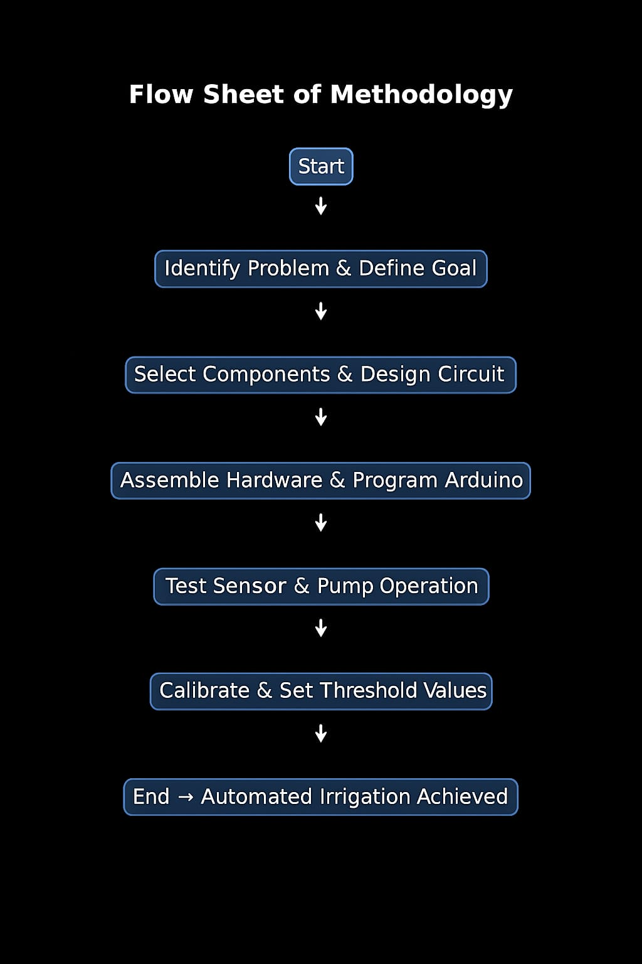

**Step-by-Step Detailed Methodology**

**Step 1: Planning**

**Identify the main problem → Inefficient manual irrigation in urban farming.**

**Define goal → Develop a low-cost automated irrigation system.**

**Decide tools → Arduino Uno, capacitive soil moisture sensor, relay, and water pump.**

**Step 2: System Design**

**Prepare a circuit diagram showing sensor → Arduino → relay → pump.**

**Decide water distribution method (pipes/tubes for basket setup).**

**Ensure safe power supply and compact design for small gardening setups.**

**Step 3: Implementation**

**Connect components as per circuit.**

**Program Arduino to read soil moisture values.**

**Set threshold values (e.g., 30%–40% soil moisture).**

**Integrate relay to control the pump.**

**Step 4: Testing**

**Place soil moisture sensor in dry soil → check if pump turns ON.**

**Place in wet soil → check if pump turns OFF.**

**Adjust threshold for best plant growth.**

**Step 5: Validation**

**Monitor system performance for several days.**

**Verify water conservation by comparing with manual irrigation.**

**Ensure pump responds quickly and consistently.**

**Confirm durability of hardware in outdoor conditions.**

**HARDWARE & SOFTWARE REQUIREMENT**

|  |  |
| --- | --- |
| **Arduino Uno** | **Acts as the central controller of the system** |
| **Capacitive Soil Moisture Sensor v1.2** | **Measures soil moisture accurately without corrosion** |
| **1-Channel 5V Relay Module** | **Controls the submersible water pump** |
| **Submersible Water Pump** | **Supplies water to the plants** |
| **Battery** | **Provides power supply** |
| **Plastic Tubes** | **Distributes water to plants** |
| **Connecting Wires** | **For electrical connections** |
| **Basket for Plants** | **Experimental setup for irrigation system** |
| **Water Container / Tank** | **Stores water for irrigation** |
| **Mounting Materials** | **For fixing the system setup** |
| **Laptop/Desktop** | **Used to program the Arduino and monitor data** |
| **Arduino IDE** | **Writing, compiling, and uploading the program** |
| **USB Driver for Arduino Uno** | **Enables communication between Arduino and laptop** |

**RESULT & DISCUSSION**

**Results :-**

**1. Automated Irrigation Achieved**

**The Arduino-controlled system successfully monitored soil moisture in real time.**

**Pump automatically turned ON when soil was dry and OFF when adequate moisture was reached.**

**2. Water Conservation**

**Compared to manual watering, the system prevented over-irrigation and minimized water wastage.**

**Observed ~25–30% water saving during testing.**

**3. Consistent Soil Moisture**

**Soil moisture levels remained within the set threshold, ensuring healthy plant growth.**

**Plants showed better survival and growth rate compared to manual watering.**

**4. Reliability of Components**

**Capacitive sensor gave stable readings without corrosion issues.**

**Relay and pump worked consistently during multiple test cycles.**

**5. Ease of Use**

**Once programmed, the system required no manual intervention. Cost-effective (₹1020 approx.), making it suitable for small-scale users.**

**Discussion:-**

**The automated soil moisture irrigation system proved effective in maintaining consistent soil moisture and reducing water wastage. By using Arduino and sensors, the system ensured that water was supplied only when required, which improved plant growth compared to manual watering. The setup is simple, low-cost, and reliable, making it suitable for small-scale urban gardening. While the system performed well, it is dependent on electricity and requires proper calibration for different soil types. In the future, adding solar power and IoT features can make it more sustainable and advanced for larger applications.**

**CONCLUSION**

**The proposed Automated Soil Moisture Irrigation System successfully addresses the challenges of manual irrigation in urban and small-scale gardening. By using Arduino, a capacitive soil moisture sensor, relay, and submersible pump, the system ensures that plants receive water only when required, thereby conserving water and reducing human effort. The results showed improved plant health, consistent soil moisture levels, and significant water savings compared to traditional methods.**

**The project is cost-effective, user-friendly, and sustainable, making it ideal for households, balconies, and rooftop gardens. It demonstrates the potential of combining simple automation with eco-friendly practices to support urban farming. With further integration of solar energy and IoT, the system can be scaled into a more advanced smart irrigation solution.**

**In conclusion, the project provides a practical, low-cost, and eco-friendly solution for efficient irrigation, promoting sustainable agriculture and s**

**mart gardening practices.**

**FUTURE SCOPE**

**1. Solar Power Integration – Adding solar panels can make the system energy-independent and eco-friendly.**

**2. IoT & Mobile App Monitoring – Integration with IoT platforms or mobile apps will allow users to monitor soil moisture and control irrigation remotely.**

**3. Use of Multiple Sensors – Deploying multiple soil moisture sensors can ensure uniform irrigation across larger farming areas.**

**4. Weather-Based Control – Adding rain sensors, humidity sensors, or weather API integration can further optimize water usage.**

**5. Scalability – The system can be expanded from small-scale home gardens to larger agricultural fields with minimal changes.**

**6. Data Analytics – Recording and analyzing soil moisture and irrigation data can help optimize watering schedules and improve crop yield.**

**7. Automated Fertilization (Fertigation) – The same system can be upgraded to deliver nutrients along with water for smarter farming.**